EASTERN AFRICA STATISTICAL TRAINING CENTRE
DSU07210 — Linux Systems Administration
Group Assignment Submission Template
Data Science Year 1 | Academic Year 2025/2026

A. Group & Assignment Information

Group & Assignment Details
Assignment No. | 1 | Session | C
Assignment Title | Linux Systems Administration
Group No. | 10 | Date Submitted | 7th June 2026
Academic Year
2025 / 2026

B. Group Members
List all group members. The Role/Task column should show which task(s) each member led.

# | Full Name | Reg. Number | Session | Role / Task
1 | FREDY RESPICHIUS MATUNGWA | EASTC/BDTS/26/04195 | 10 C | Group organizer& Led Task 1 report wrote
2 | TEKLA JOHN MKUDE | EASTC/BDTS/25/02469 | 10 C | Code verifier and report wrote( self)
3 | MARIA AGUSTINO KIKOTI | EASTC/BDTS/26/04694 | 10 C | Led Task 4 & creativity idea bringer
4 | GLORY PETER SALUM | EASTC/BDTS/26/04583 | 10 C | Led Task 5 & creativity idea
5 | KELVIN EMANUEL SILVESTA | EASTC/BDTS/25/01903 | 10 C | Led Task 2 &3 Screenshot
C. Assignment Instructions Summary
Before starting, re-read the full assignment from your lecturer. Then tick the boxes below as you complete each task.

- Every command must be run on a real Linux terminal.
- Screenshots or terminal recordings are required as evidence.
- Complete the Creativity Challenge with a scenario your group designs.
- Each member completes the Self-Exploration section individually.
- Submit this template as your group report (printed or PDF).
D. Task Completion Checklist
For each task: briefly describe what your group did, mark whether it is complete, and note the evidence (e.g. screenshot filename or page number in your terminal log).

# | Task Description (summarise what you did) | Done? (Yes/No) | Evidence
1 | We start task by creating 3 directory Files namely { company/hr/record ,company/it/scripts and company/finance/report using mkdr command | Yes done | 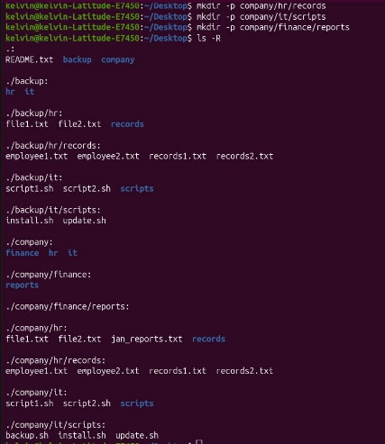
2 | We populate our files in a directory into 2 placeholder using touch command | Yes done | 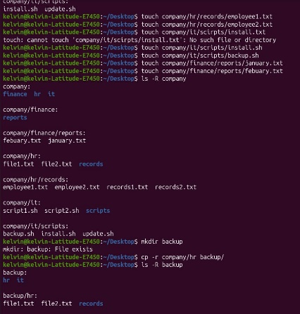
3 | After populate we copy one entire department folder to a new location called backup/. | Yes done | 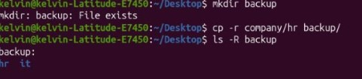
4 | By using mv command we resume a File and move it across two directory lever | Yes done | 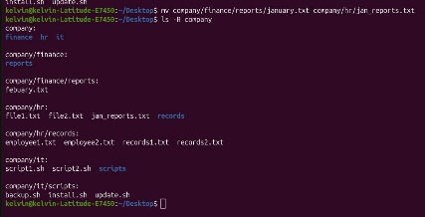
5 | Finally we safely delete an empty directory files using rmdir and non-empty one using rm- | Yes done | 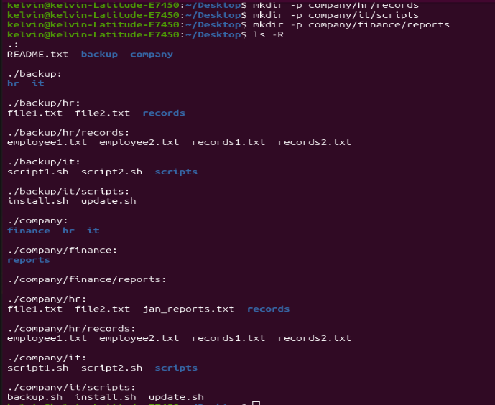

E. Command Evidence Log
Record the key commands your group ran. Attach screenshots after this page or include terminal output in an appendix.

# | Task Ref. | Command(s) Run / Description | Screenshot?
1 | Task 1 | mkdr –p company/hr/record company/it/script and company/finance/report  (create a 3-lever directory tree structure) | 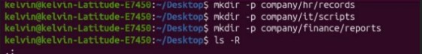
2 | Task 2 | (To populate the directory with placeholder files)  Command:  touch company/hr/record/file.txt  touch company/it/script/file.txt
3 | Task 3 | (We copy the entire foldler to a new backup location)  Command:  cr –r company/ backup/ | 
4 | Task 4 | ( Renames and move a file across two levels)  Command:  mv company/hr/record/file1.txt  mv company/it/script/new_file.
5 | Task 5 | (Delete an empty file in directory file and non-empty file)  Command: | 

F. Creativity Challenge
Describe the real-world scenario your group chose and explain your creative design decisions.

Creativity Challenge
Scenario we chose:
School Management System
Our group designed a directory structure for a secondary school. The folders represented different departments within the school.

Our creative approach:
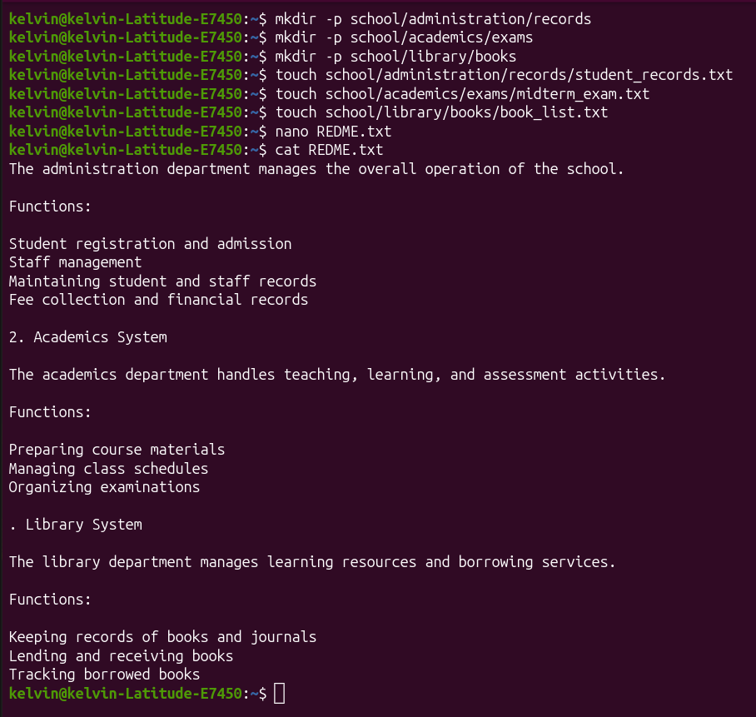

G. Self-Exploration (Individual — one per member)
Each group member must complete their own copy of this section. Photocopy this page or attach separate sheets — one per member.

Student Name:
TEKLA JOHN MKUDE | EASTC/BDTS/25/02469

Self-Exploration Findings
Exploration question answered:

Difference between ls -la and ls -l

Key commands tested:
ls -l displays files and directories in long format.
ls -la displays all files, including hidden files that begin with a dot (.).

What I discovered:
ls --color
Files and directories appeared in different colors, making them easier to identify.

ls -R
The command displayed all directories and their contents recursively, including subdirectories.

H. Group Member Contributions
Briefly describe what each member contributed. The percentages must add up to 100% per task (or you can distribute overall contribution).

Member Name | Specific Contribution | % Contribution
FREDY RESPICHIUS MATUNGWA | Ran command for task 1 and Formulate final report layout and verified and declear whole report | 20%
KELVN EMANUEL SILVESTA | Excute Task 2 and 3 ( touch and backup creation) and capture all screenshot | 20%
MARIA AGUSTINO KIKOTI | Solve Task 4 and provide an idea for the Creativity Challenge design | 20%
GLORY PETER SALIM | Solve Task 5 and also bring an idea for our Creativity Challenge design | 20%
TEKLA JOHN MKUDE | Participate in solving tasks by verified commands also wrote the individual Self_Exploration report | 20%
EASTC | DSU07210 Linux Systems Administration | 2025/2026

EASTERN AFRICA STATISTICAL TRAINING CENTRE
DSU07210 — Linux Systems Administration
Group Assignment Submission Template
Data Science Year 1 | Academic Year 2025/2026

A. Group & Assignment Information

Group & Assignment Details
Assignment No. | 02 | Session | C
Assignment Title | Linux Systems Administration
Group No. | 10 | Date Submitted | 7th June 2026
Academic Year
2025 / 2026

B. Group Members
List all group members. The Role/Task column should show which task(s) each member led.

# | Full Name | Reg. Number | Session | Role / Task
1 | FREDY RESPICHIUS MATUNGWA | EASTC/BDTS/26/04195 | 10 C | Group organizer,led task 1
2 | TEKLA JOHN MKUDE | EASTC/BDTS/25/02469 | 10 C | Led task 4 and creativity idea
3 | MARIA AGUSTINO KIKOTI | EASTC/BDTS/26/04694 | 10 C | Led task 5 and code verfied
4 | GLORY PETER SALUM | EASTC/BDTS/26/04583 | 10 C | Led task 3 and creativity idea
5 | KELVIN EMANUEL SILVESTA | EASTC/BDTS/25/01903 | 10 C | Led task 2 and screenshots
C. Assignment Instructions Summary
Before starting, re-read the full assignment from your lecturer. Then tick the boxes below as you complete each task.

- Every command must be run on a real Linux terminal.
- Screenshots or terminal recordings are required as evidence.
- Complete the Creativity Challenge with a scenario your group designs.
- Each member completes the Self-Exploration section individually.
- Submit this template as your group report (printed or PDF).

D. Task Completion Checklist
For each task: briefly describe what your group did, mark whether it is complete, and note the evidence (e.g. screenshot filename or page number in your terminal log).

# | Task Description (summarise what you did) | Done? (Yes/No) | Evidence
1 | We firstly create a text file name Hobbies tha consist of exactly 30 line of content about cryptocurrency | Yes | 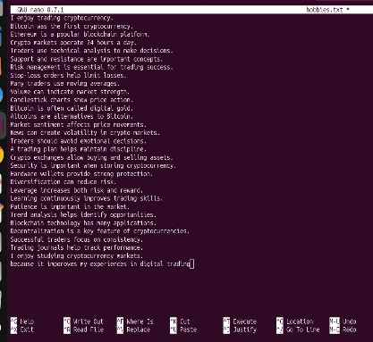
2 | We use head and tail command to display exactly the 5 first line of the file txt and 5 last 5 line of our txt file called hobbies | Yes | 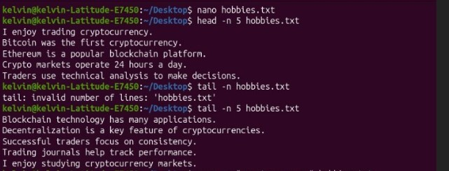
3 | We also use grep command to search for the selected word cryptocurrency and manage to display matching line with line numbes | Yes | 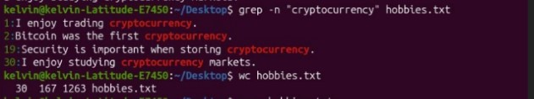
4 | By using command wc we manage to count word,line and character in your file txt hobbies | Yes
5 | We open the file hobbies in nano, edit and save it again. Finally we reopen it in cat to verfy changes | Yes | 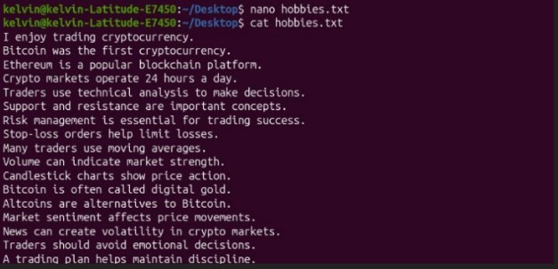

E. Command Evidence Log
Record the key commands your group ran. Attach screenshots after this page or include terminal output in an appendix.

# | Task Ref. | Command(s) Run / Description | Screenshot?
1 | Task 1 | (nano command we use it to create and text file called hobbies with 30 line distoratory)  Command:  $ nano hobbies.txt | 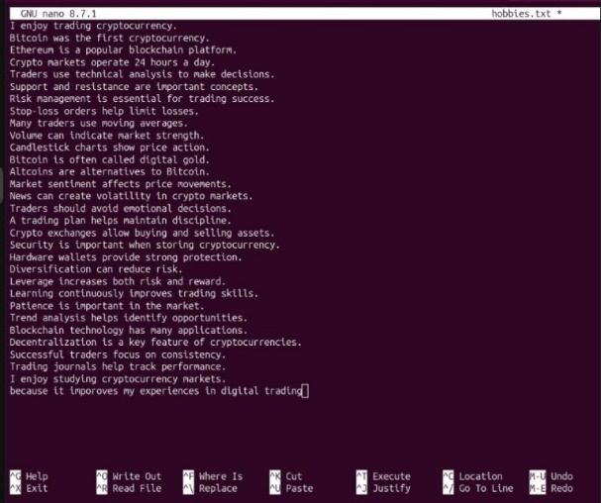
2 | Task 2 | ( we use command head and tail to show all line first and last line in our file txt hobbies)  Command:  $ head –n 5 hobbies.txt  $ tail –n 5 hobbies.txt | 
3 | Task 3 | (command grep used to show a specific word selected in our file txt hobbies)  Command:  $ grep –n “cryptocurrency” hobbies.txt | 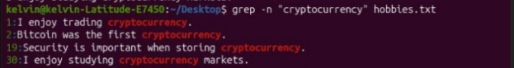
4 | Task 4 | (we use command wc to list all character,line and word present in our file txt hobbies)  Command:  wc hobbies.txt
5 | Task 5 | Command:  nano hobbies.txt  cat hobbies.txt  (we use nano to open file, edit and save again. We use cat to reopen again and verfy) | 

F. Creativity Challenge
Describe the real-world scenario your group chose and explain your creative design decisions.

Creativity Challenge
Scenario we chose:
Mini Log Simulator
We created a simulated system log file containing events such as user logins, file access, and errors.

Our creative approach:
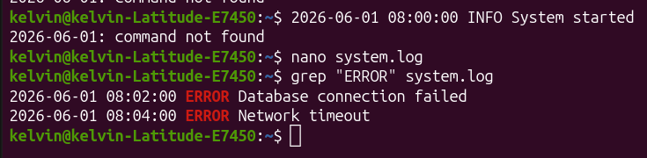

G. Self-Exploration (Individual — one per member)
Each group member must complete their own copy of this section. Photocopy this page or attach separate sheets — one per member.

Student Name:
MARIA AGUSTINO KIKOTI | EASTC/BDTS/26/04694

Self-Exploration Findings
Exploration question answered:

Difference between cat, less, and more

Key commands tested:

cat
more
less

What I discovered:
cat displays the entire file at once.
more displays one screen at a time.
less allows forward and backward navigation through the file.

H. Group Member Contributions
Briefly describe what each member contributed. The percentages must add up to 100% per task (or you can distribute overall contribution).

Member Name | Specific Contribution | % Contribution
FREDY RESPICHIUS MATUNGWA | Perforn Task 1 and wrote a report | 20%
KELVN EMANUEL SILIVESTA | Run and perform task 2 as well as take screenshots | 20%
GLORY PETER SALUM | Perform task 3 and outline | 20%
TEKLA JOHN MKUDE | Perform Task 4 | 20%
MARIA AGUSTINO KIKOTI | Run command for Task 5 | 20%

EASTERN AFRICA STATISTICAL TRAINING CENTRE
DSU07210 — Linux Systems Administration
Group Assignment Submission Template
Data Science Year 1 | Academic Year 2025/2026

A. Group & Assignment Information

Group & Assignment Details
Assignment No. | 04 | Session | C
Assignment Title | Linux Systems Administration
Group No. | 10 | Date Submitted | 7th June 2026
Academic Year
2025 / 2026

B. Group Members
List all group members. The Role/Task column should show which task(s) each member led.

# | Full Name | Reg. Number | Session | Role / Task
1 | FREDY RESPICHIUS MATUNGWA | EASTC/BDTS/26/04195 | 10 C | Lab supervisor
2 | TEKLA JOHN MKUDE | EASTC/BDTS/25/02469 | 10 C | Screenshots and quality control
3 | MARIA AGUSTINO KIKOTI | EASTC/BDTS/26/04694 | 10 C | Quality control& screenshot
4 | GLORY PETER SALUM | EASTC/BDTS/26/04583 | 10 C | Lead technical writer
5 | KELVIN EMANUEL SILVESTA | EASTC/BDTS/25/01903 | 10 C | Terminal operator
6

C. Assignment Instructions Summary
Before starting, re-read the full assignment from your lecturer. Then tick the boxes below as you complete each task.

- Every command must be run on a real Linux terminal.
- Screenshots or terminal recordings are required as evidence.
- Complete the Creativity Challenge with a scenario your group designs.
- Each member completes the Self-Exploration section individually.
- Submit this template as your group report (printed or PDF).
D. Task Completion Checklist
For each task: briefly describe what your group did, mark whether it is complete, and note the evidence (e.g. screenshot filename or page number in your terminal log).

# | Task Description (summarise what you did) | Done? (Yes/No) | Evidence
1 | Firstly we run a long-running process in the background called ( sleep 300) and use ps command to find the process PID | Yes | 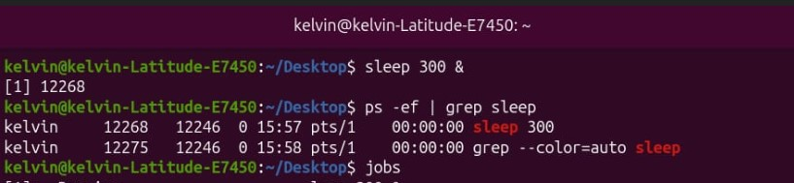  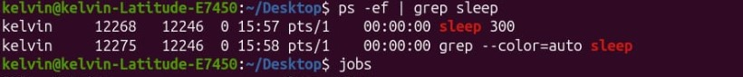  Hence PID values: [1] 122268
2 | As group wer use jobs command to list background jobs and bring one to the foreground using command fg | Yes | 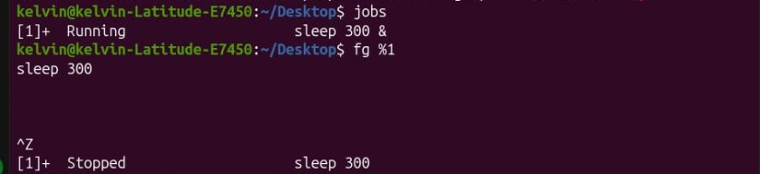
3 | We launch top and identify the process consuming the most CPU – and by that we take a screenshot | Yes | 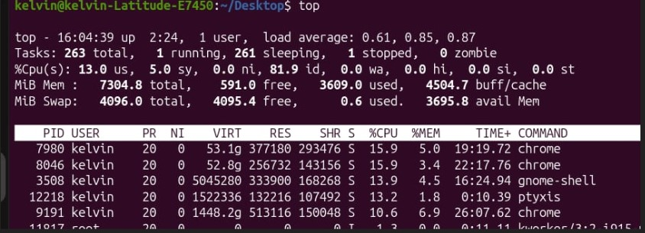  Hence the top consumption process are:  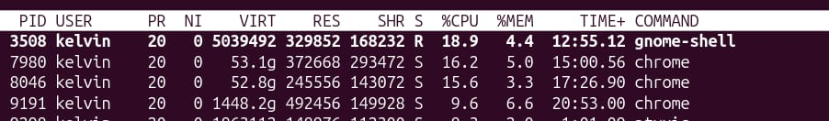  - Grone-shell 18.9%  - Chome 16.2%  - Chrome 15.6%
4 | By using kill command we terminate a process by both PID but also by name | Yes | 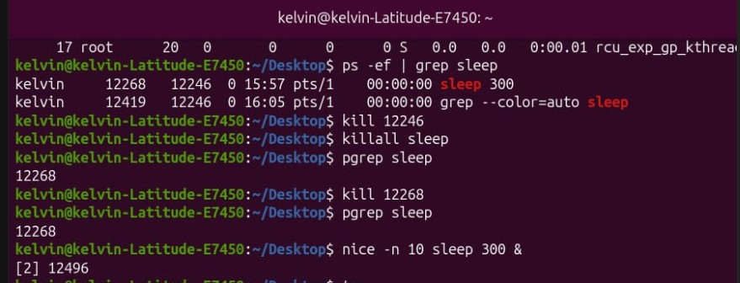
5 | We run command with nice –n 10 and kindly we folloup how it appear in top | Yes | 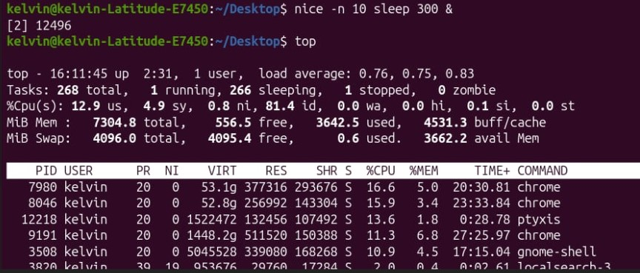

E. Command Evidence Log
Record the key commands your group ran. Attach screenshots after this page or include terminal output in an appendix.

# | Task Ref. | Command(s) Run / Description | Screenshot?
1 | Task 1 | Command: sleep 300  ( Start a long-running process in the background)  Ps –ef | grep sleep  (List running process to find the PID of the sleep command ) | 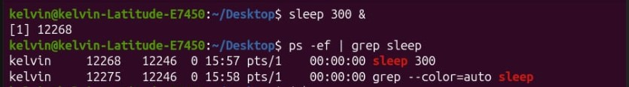
2 | Task 2 | Command: jobs  ( list all current active background jobs on the sytems)  fg %1  (Used to brong background number 1 to the foreground) | 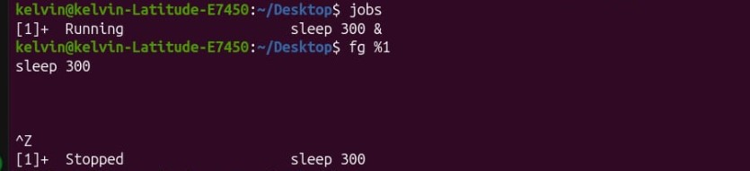
3 | Task 3 | Command: top  (launches the interactive process monitor to the identify the highest CPU-cunsuming process | 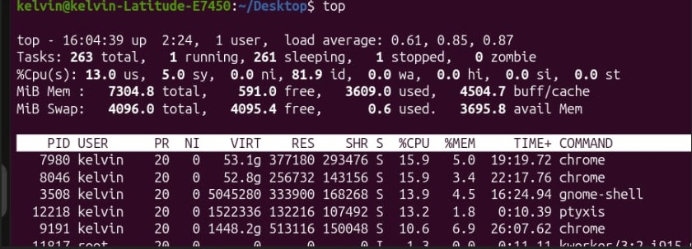
4 | Task 4 | Command: kill 122246  ( terminate all running process using its process ID-PID)  Killall sleep  ( Terminate all runnimg instances of thr process by name) | 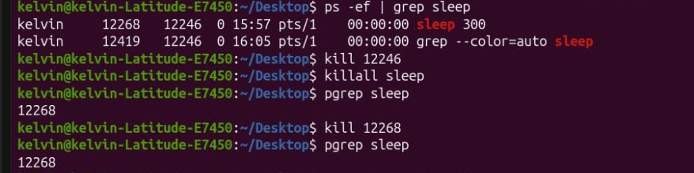
5 | Task 5 | Command : nice –n 10 sleep 500  (launches a new process with an altered/reduced priority level) | 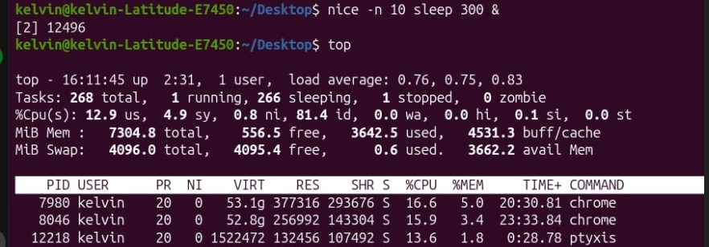

F. Creativity Challenge
Describe the real-world scenario your group chose and explain your creative design decisions.

Creativity Challenge
Scenario we chose:
Script to Manage Background Jobs

Our creative approach:
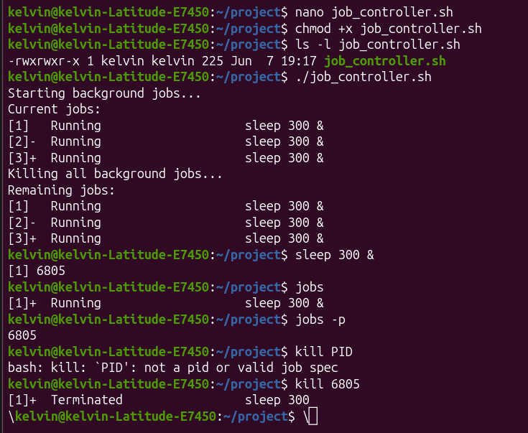

G. Self-Exploration (Individual — one per member)
Each group member must complete their own copy of this section. Photocopy this page or attach separate sheets — one per member.

Student Name: Reg. No.: _______

GLORY PETER SALUM | EASTC/BDTS/26/04583

Self-Exploration Findings
Exploration question answered:

Difference between kill -15 and kill -9

Key commands tested:
kill -15
kill -9

What I discovered:
kill -15
Allows the program to close properly.
kill -9
Forces immediate termination.

H. Group Member Contributions
Briefly describe what each member contributed. The percentages must add up to 100% per task (or you can distribute overall contribution).

Member Name | Specific Contribution | % Contribution
FREDY RESPICHIUS MATUNGWA | Running Task 1 & code verified | 20%
TEKLA JOHN MKUDE | Running task 2 | 20%
MARIA AGUSTINO KIKOTI | Running task 3 | 20%
GLORY PETER SALUM | Runing Task 4 and write a report | 20%
KELVIN EMANUEL SILVESTA | Running Task 5 and take screenshots,leadt Technical writer | 20%
J. Declaration
We declare that this is our own group work. All commands were run on a real Linux system. All members participated as recorded above. We have not copied work from another group.

Group Leader Signature:

Date: ____________________________

EASTC | DSU07210 Linux Systems Administration | 2025/2026

EASTERN AFRICA STATISTICAL TRAINING CENTRE
DSU07210 — Linux Systems Administration
Group Assignment Submission Template
Data Science Year 1 | Academic Year 2025/2026

A. Group & Assignment Information

Group & Assignment Details
Assignment No. | 05 | Session | C
Assignment Title | Linux Systems Administration
Group No. | 10 | Date Submitted | 7th June 2026
Academic Year
2025 / 2026

B. Group Members
List all group members. The Role/Task column should show which task(s) each member led.

# | Full Name | Reg. Number | Session | Role / Task
1 | FREDY RESPICHIUS MATUNGWA | EASTC/BDTS/26/04195 | 10 C | Led command 1 and 2
2 | TEKLA JOHN MKUDE | EASTC/BDTS/25/02469 | 10 C | Led command 3
3 | MARIA AGUSTINO KIKOTI | EASTC/BDTS/26/04694 | 10 C | Led command 4
4 | GLORY PETER SALUM | EASTC/BDTS/26/04583 | 10 C | Run command 5
5 | KELVIN EMANUEL SILVESTA | EASTC/BDTS/25/01903 | 10 C | Group organizer and creativity idea
6

C. Assignment Instructions Summary
Before starting, re-read the full assignment from your lecturer. Then tick the boxes below as you complete each task.

- Every command must be run on a real Linux terminal. √
- Screenshots or terminal recordings are required as evidence. √
- Complete the Creativity Challenge with a scenario your group designs. √
- Each member completes the Self-Exploration section individually. √
- Submit this template as your group report (printed or PDF).√
D. Task Completion Checklist
For each task: briefly describe what your group did, mark whether it is complete, and note the evidence (e.g. screenshot filename or page number in your terminal log).

# | Task Description (summarise what you did) | Done? (Yes/No) | Evidence
1 | We use df –h command to display data usage of all mounted filesytem and identify the roof partition | Yes done | 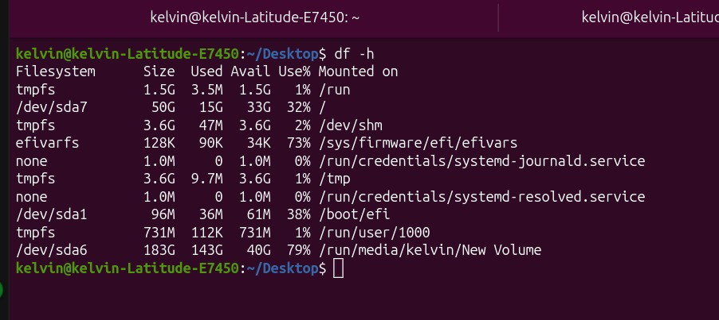
2 | We use command du –sh on different directories and compare their sizes | Yes done | 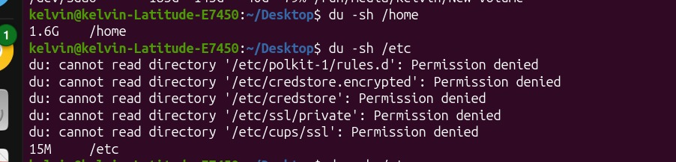
3 | Then we create a tz.gz achieve of a directory, we verify its contents with tar –tvf command, then we extract it to a new location | Yes done | 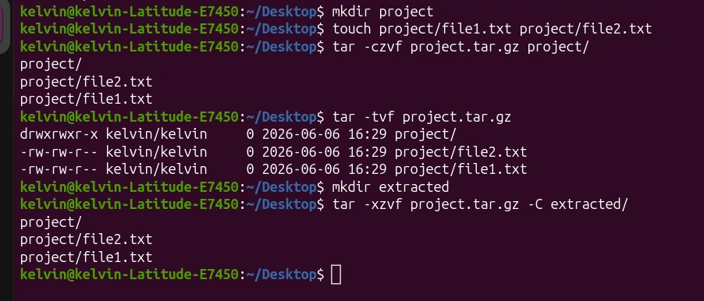
4 | We use lsblk command to list all block divices and describe the output | Yes done | 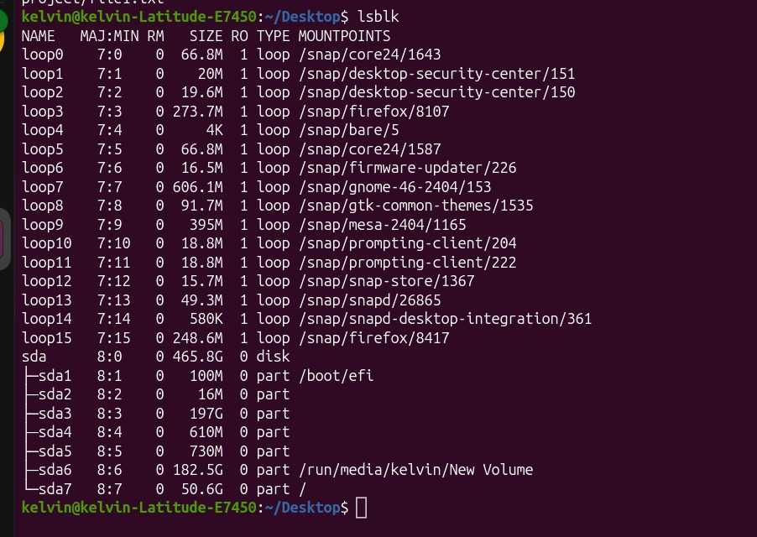
5 | Finally we compress a file with grip and then we compare its size before and after compress a file | Yes done | 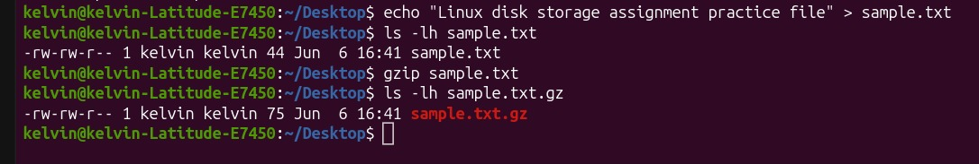

E. Command Evidence Log
Record the key commands your group ran. Attach screenshots after this page or include terminal output in an appendix.

# | Task Ref. | Command(s) Run / Description | Screenshot?
1 | Task 1 | Command: bash  df –h  (This diplay all mounted filesytems) | 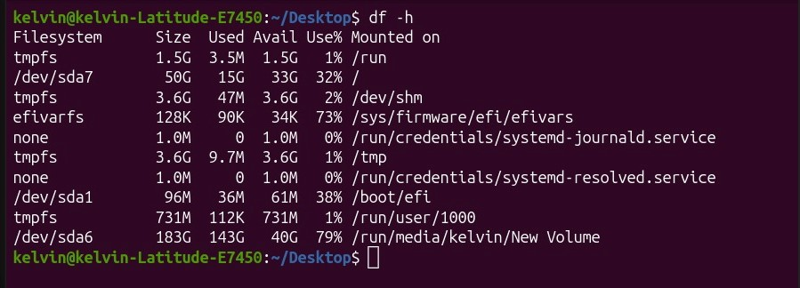
2 | Task 2 | Command: bash  du –sh Documents/Download/ Desktop/  ( This –s flag provide a summary total for each folder and –h make human-readable in MB or GB) | 
3 | Task 3 | Command: tar –czf backup.tar.gz Documents/  tar –tvf backup.tar.gz  tar -xzf backup.tar.gz –C /tmp/  ( These are used to create the archives, verify/list content without exctract and Extract to a new location respectivery ) | 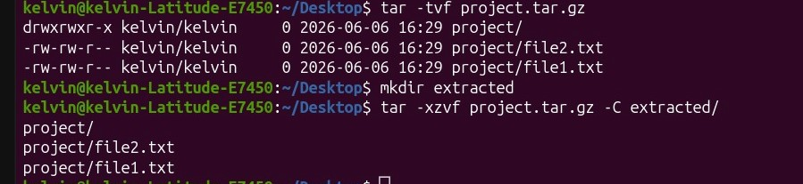
4 | Task4 | Command: lsblk  ( This show a visual tree of your storage divice like sda,sdb or nvme0n1 along their partitions) | 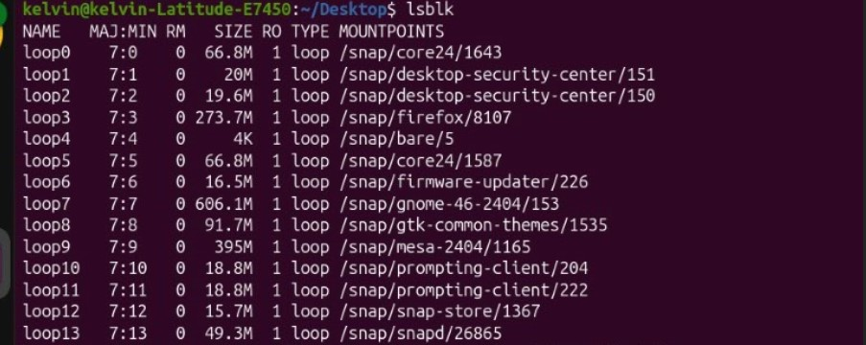
5 | Task 5 | Command:  gzip  ls –l large_file.txt  gzip large_file.txt  ls –l large_file.txt.gz  ( the command above used to compress a single file using gzip and compae size, check compressed file size) | 

F. Creativity Challenge
Describe the real-world scenario your group chose and explain your creative design decisions.

Creativity Challenge
Scenario we chose:
Backup Simulation
We created a backup archive:
tar -czf project_2025-06-01.tar.gz project/
Daily Cron Job
0 1 * * * tar -czf /backup/project_$(date +\%F).tar.gz /project
This command automatically creates a compressed backup every day at 1:00 AM.

Our creative approach:
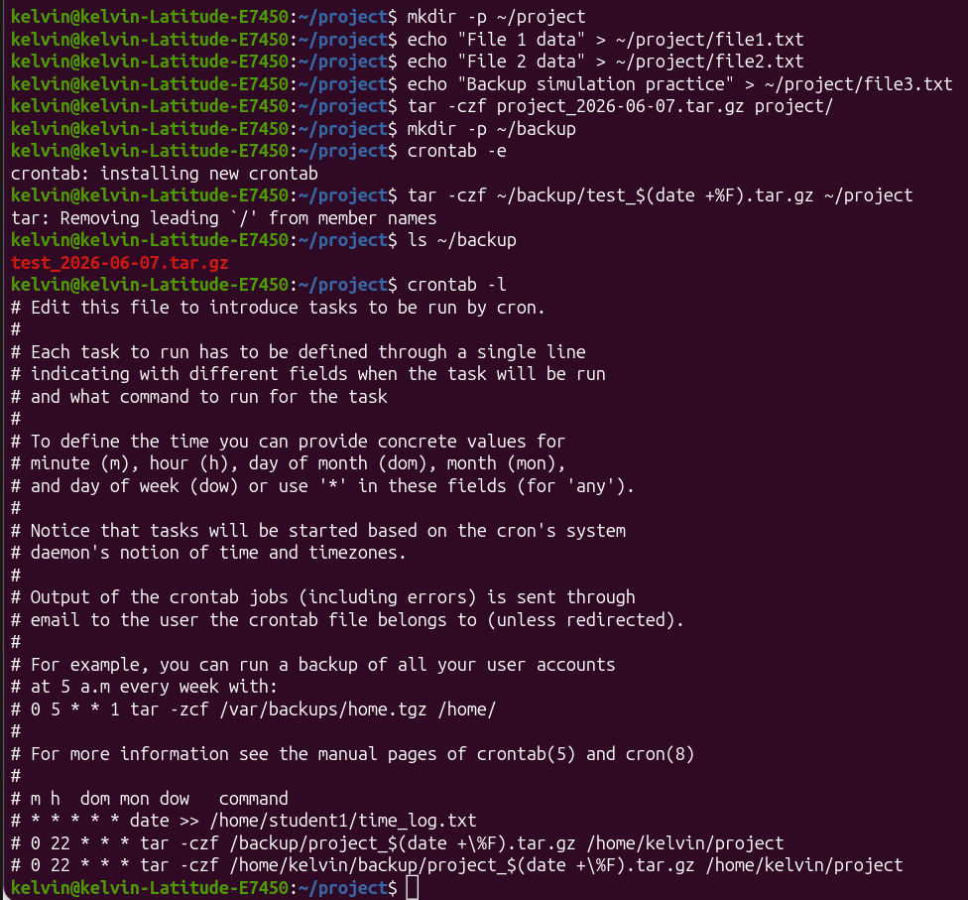

G. Self-Exploration (Individual — one per member)
Each group member must complete their own copy of this section. Photocopy this page or attach separate sheets — one per member.

Student Name: KELVIN EMANUEL SILVESTA Reg. No.: EASTC/BDTS/25/01903
Self-Exploration Findings
Exploration question answered:

Difference between tar -czf and tar -cjf

Key commands tested:
tar -czf
Uses Gzip compression.

tar -cjf
Uses Bzip2 compression.

What I discovered:
Gzip is faster.
Bzip2 usually creates smaller archives.
Bzip2 requires more processing time.

H. Group Member Contributions
Briefly describe what each member contributed. The percentages must add up to 100% per task (or you can distribute overall contribution).

Member Name | Specific Contribution | % Contribution
FREDY RESPICHIUS MATUNGWA | Run task 3 and 4 error verify | 20%
KELVIN EMANUEL SILVESTA | Lab supervisor and group organizer | 20%
GLORY PETER SALUM | Run task 5 and wrote report files | 20%
MARIA AGUSTINO KIKOTI | Run task 2 | 20%
TEKLA JOHN MKUDE | Run task 1 | 20%
J. Declaration
We declare that this is our own group work. All commands were run on a real Linux system. All members participated as recorded above. We have not copied work from another group.

Group Leader Signature:

Date: ____________________________

EASTC | DSU07210 Linux Systems Administration | 2025/2026

EASTERN AFRICA STATISTICAL TRAINING CENTRE
DSU07210 — Linux Systems Administration
Group Assignment Submission Template
Data Science Year 1 | Academic Year 2025/2026

A. Group & Assignment Information

Group & Assignment Details
Assignment No. | 06 | Session | C
Assignment Title | Networking
Group No. | 10 | Date Submitted | 7th June 2026
Academic Year
2025 / 2026

B. Group Members
List all group members. The Role/Task column should show which task(s) each member led.

# | Full Name | Reg. Number | Session | Role / Task
1 | FREDY RESPICHIUS MATUNGWA | EASTC/BDTS/26/04195 | 10 C | Led command 1 and 4
2 | TEKLA JOHN MKUDE | EASTC/BDTS/25/02469 | 10 C | Led command 3
3 | MARIA AGUSTINO KIKOTI | EASTC/BDTS/26/04694 | 10 C | Led command 2
4 | GLORY PETER SALUM | EASTC/BDTS/26/04583 | 10 C | Run command 5
5 | KELVIN EMANUEL SILVESTA | EASTC/BDTS/25/01903 | 10 C | Group organizer and creativity idea

C. Assignment Instructions Summary
Before starting, re-read the full assignment from your lecturer. Then tick the boxes below as you complete each task.

- Every command must be run on a real Linux terminal. √
- Screenshots or terminal recordings are required as evidence. √
- Complete the Creativity Challenge with a scenario your group designs. √
- Each member completes the Self-Exploration section individually. √
- Submit this template as your group report (printed or PDF).√

D. Task Completion Checklist
For each task: briefly describe what your group did, mark whether it is complete, and note the evidence (e.g. screenshot filename or page number in your terminal log).

# | Task Description (summarise what you did) | Done? (Yes/No) | Evidence
1 | We firstly use an ip addr command to display our network interfance detail and followard by note our IP address | Yes done | 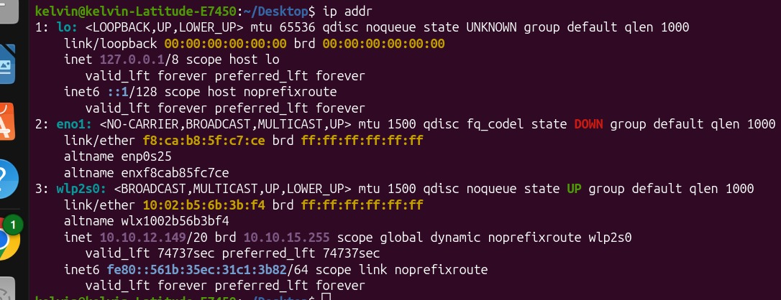  Hence our IP address are:  127.0.0.1/8 scope  10.10.12.149/20
2 | We ping a public server 5 times using a flags and we observe a packet loss( server we use is google.com) | Yes done | 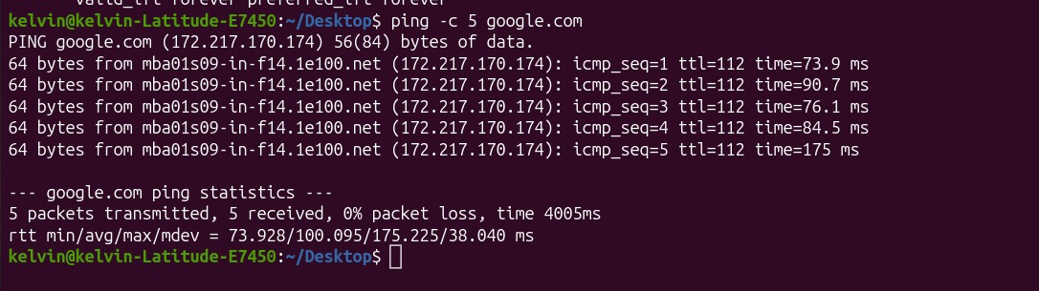
3 | We use an curl command to fetch a webpage’s HTTP headers only | Yes done | 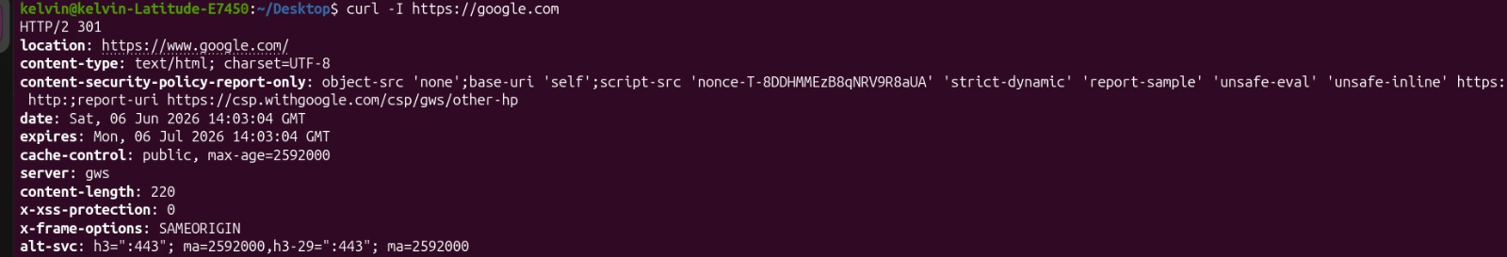
4 | We manage to download a small public files and verify its size using wget command | Yes done | 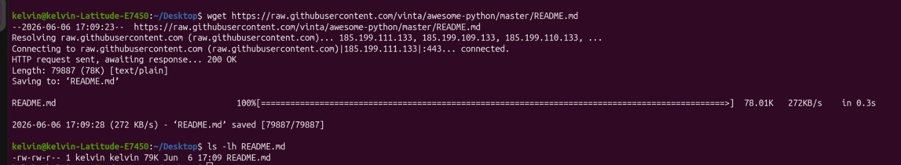
5 | We use ss –tuln to list all listerning ports and identify at least 2 | Yes done | 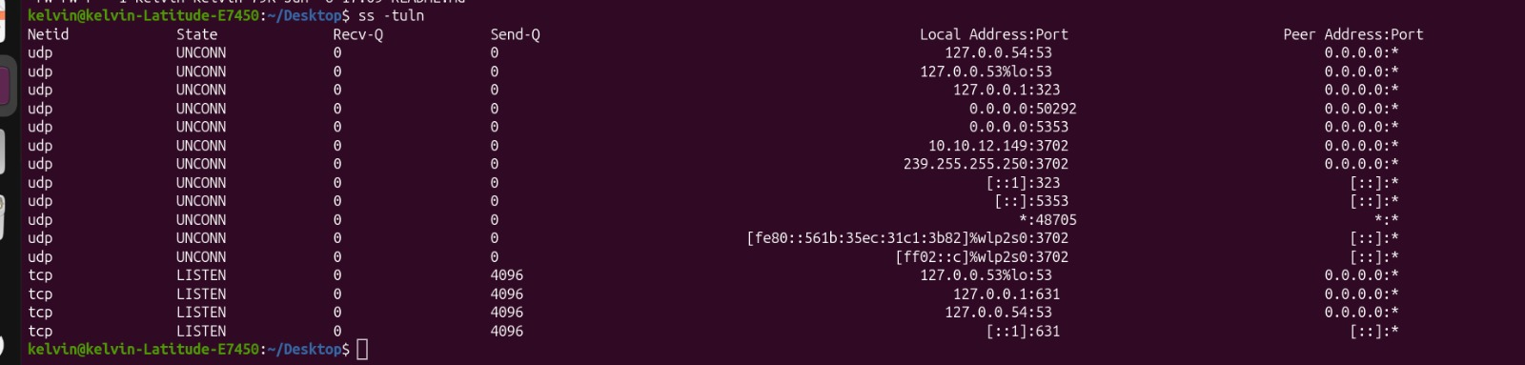  The following are 2 listing parts we observed

E. Command Evidence Log
Record the key commands your group ran. Attach screenshots after this page or include terminal output in an appendix.

# | Task Ref. | Command(s) Run / Description | Screenshot?
1 | Task 1 | Command: ip a  Or  Ifconfing  (we usethis command to show our network interface card such as eth0 etc and our active IP addresses) | Refers on screenshot for task 1 in c
2 | Task 2 | Command: ping –c 4 google.com  (The –c 4 flag limit the ping to exactly 4 packets so that it stop automatically preventing an endless terminal scoll) | Task 2 in C
3 | Task 3 | Command: traceroute google.com  ( if traceroute is not installes on our sytem we can use tracepath google.com to see the hops our data takes to reach the server) | Task 3 in C
4 | Task4 | Command: ss –tuln  (This command to display an active listing TCP and UDP sockets along with port numbers)
5 | Task 5 | Command: dig googles.com  ( This command perform a DNS lookup to the retrieve domain name resources record) | Task 5 in C
F. Creativity Challenge
Describe the real-world scenario your group chose and explain your creative design decisions.

Creativity Challenge
Scenario we chose:
Network Health Report
IP Address
The IP address identified the machine on the local network.
Gateway
The default gateway handled communication outside the local network.
DNS Server
DNS translated domain names into IP addresses.

Our creative approach:
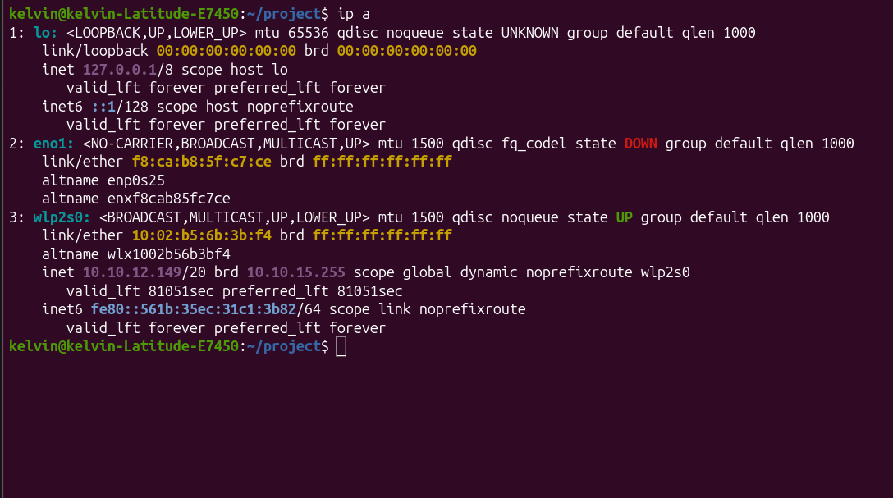

G. Self-Exploration (Individual — one per member)
Each group member must complete their own copy of this section. Photocopy this page or attach separate sheets — one per member.

Student Name: ________________________________ Reg. No.: ___________________________

Self-Exploration Findings
Exploration question answered:

Difference between netstat and ss
- ss is newer and faster.
- netstat is older and may not be installed by default.

Key commands tested:
host
dig

What I discovered:
host gives simple DNS information.
dig provides detailed DNS records and query information.

H. Group Member Contributions
Briefly describe what each member contributed. The percentages must add up to 100% per task (or you can distribute overall contribution).

Member Name | Specific Contribution | % Contribution
FREDY RESPICHIUS MATUNGWA | Run task 1 and 4 error verify | 20%
KELVIN EMANUEL SILVESTA | Lab supervisor and group organizer | 20%
GLORY PETER SALUM | Run task 5 and wrote report files | 20%
MARIA AGUSTINO KIKOTI | Run task 2 | 20%
TEKLA JOHN MKUDE | Run task 3 | 20%

EASTC | DSU07210 Linux Systems Administration | 2025/2026

EASTERN AFRICA STATISTICAL TRAINING CENTRE
DSU07210 — Linux Systems Administration
Group Assignment Submission Template
Data Science Year 1 | Academic Year 2025/2026

A. Group & Assignment Information

Group & Assignment Details
Assignment No. | 07 | Session | C
Assignment Title | Linux Systems Administration
Group No. | 10 | Date Submitted | 7th June 2026
Academic Year
2025 / 2026

B. Group Members
List all group members. The Role/Task column should show which task(s) each member led.

# | Full Name | Reg. Number | Session | Role / Task
1 | FREDY RESPICHIUS MATUNGWA | EASTC/BDTS/26/04195 | 10 C | Core task Practitioner and report wroter
2 | TEKLA JOHN MKUDE | EASTC/BDTS/25/02469 | 10 C | Lead technical writer
3 | MARIA AGUSTINO KIKOTI | EASTC/BDTS/26/04694 | 10 C | Report editor and screenshoter
4 | GLORY PETER SALUM | EASTC/BDTS/26/04583 | 10 C | Quality control and sreenshots
5 | KELVIN EMANUEL SILVESTA | EASTC/BDTS/25/01903 | 10 C | Core task practitioner and challenge disigner
6

C. Assignment Instructions Summary
Before starting, re-read the full assignment from your lecturer. Then tick the boxes below as you complete each task.

- Every command must be run on a real Linux terminal. √
- Screenshots or terminal recordings are required as evidence. √
- Complete the Creativity Challenge with a scenario your group designs. √
- Each member completes the Self-Exploration section individually. √
- Submit this template as your group report (printed or PDF).√

D. Task Completion Checklist
For each task: briefly describe what your group did, mark whether it is complete, and note the evidence (e.g. screenshot filename or page number in your terminal log).

# | Task Description (summarise what you did) | Done? (Yes/No) | Evidence
1 | We create a new user account and also set a password for our user account called students | Yes done | 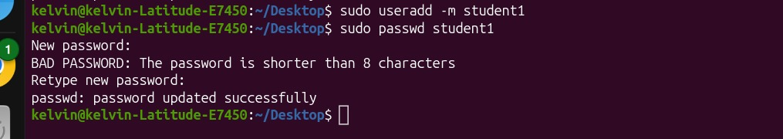
2 | Then we add the user student to the group and verify with id and group | Yes done | 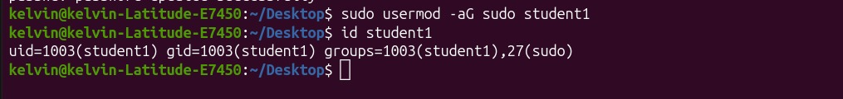
3 | We then switch to the new user with su command and we explore what they can and cannot do | Yes done | 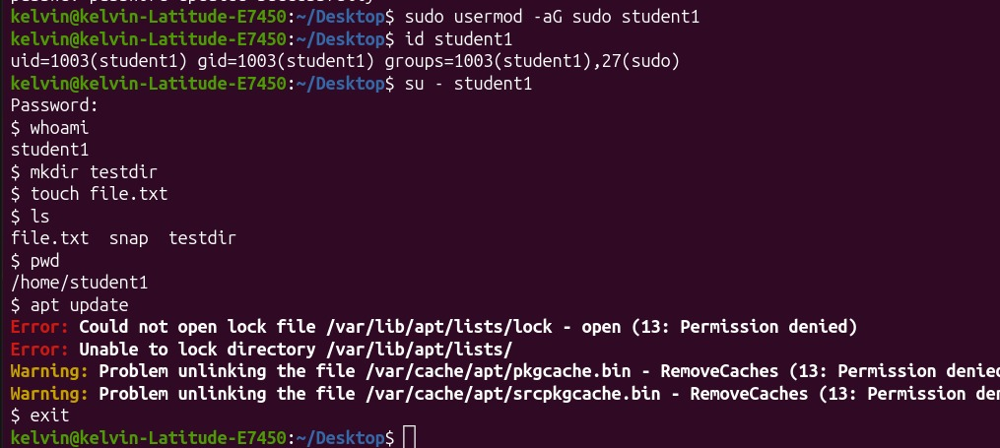  The thing we explore new user can do  - User can create an file text new file  - User can move the file txt using touch command  - User can display the existing file in directory  Thing user can not do  - Lock directory  - Open an private file which are locked by admin
4 | We use crontab –e command to write s cron job that appends the current date to log files every minute in new user | Yes done | 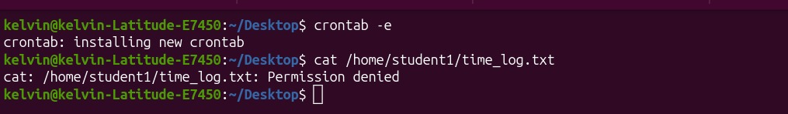
5 | We use sytemctl to check the status of at least 2 running services and restart one | Yes done | 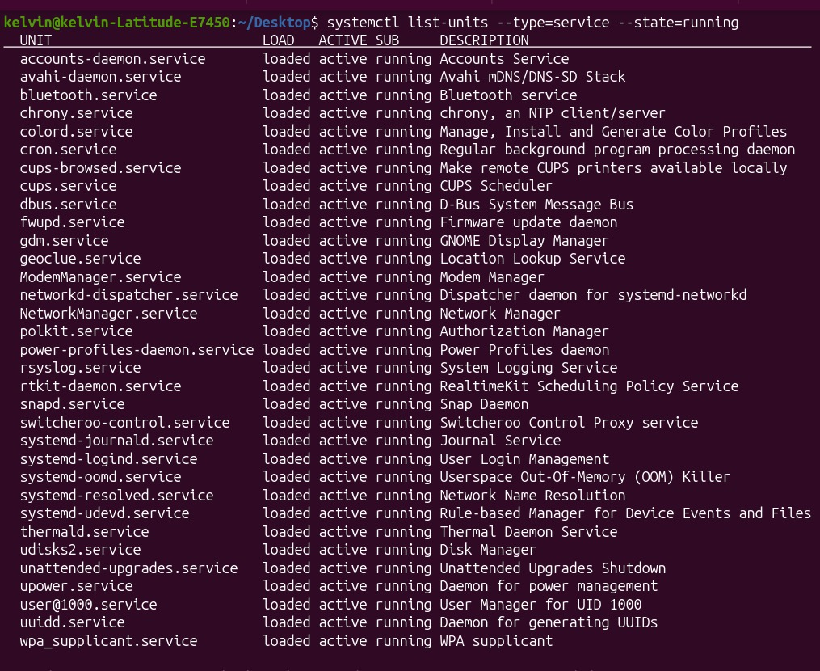

E. Command Evidence Log
Record the key commands your group ran. Attach screenshots after this page or include terminal output in an appendix.

# | Task Ref. | Command(s) Run / Description | Screenshot?
1 | Task 1 | Command: sudo useradd –m –s student1  Sudo password student1 | Refers on screenshot Task 1 C
2 | Task 2 | Command: sudo usermod –ag developer student1  Sudo usermode –aG sudo student1  Id student1  Sudo chage –l student1  (queries active user ID parameters, group record and password policy aging states) | Refers screenshot Task 2 C
3 | Task 3 | Command:we test for update  Pwd  /home/student1  apt update | Refersscreenshot Task 3 C
4 | Task4 | Command: crntab –e  Cat /home/student1/time_log.txt | Screenshot task 4 C
5 | Task 5 | Commend  : systemctl list –units –type=service –state=running | Screenschot Task 5 C

F. Creativity Challenge
Describe the real-world scenario your group chose and explain your creative design decisions.

Creativity Challenge
Scenario we chose:
New Employee Onboarding Script

Our creative approach:
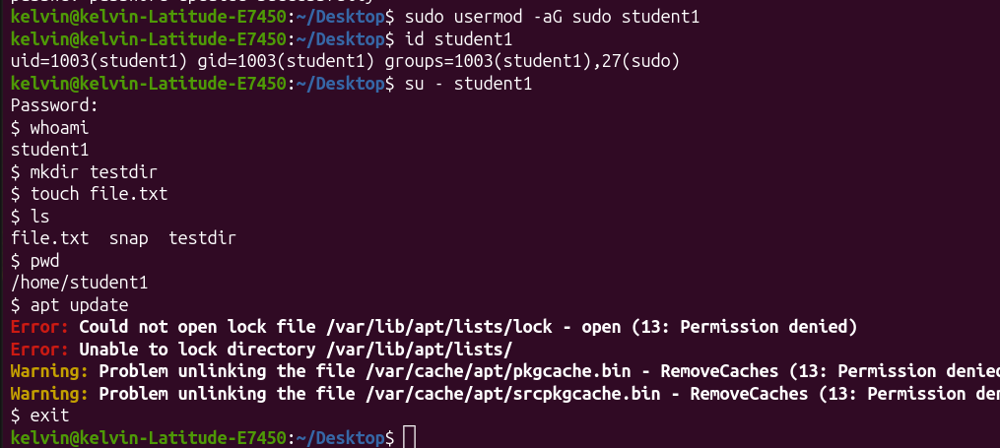

G. Self-Exploration (Individual — one per member)
Each group member must complete their own copy of this section. Photocopy this page or attach separate sheets — one per member.

Student Name:
FREDY RESPICHIUS MATUNGWA | EASTC/BDTS/26/04195

Self-Exploration Findings
Exploration question answered:
Difference between sudo su, sudo -i, and sudo -s

Key commands tested:
sudo su, sudo -i, and sudo -s

What I discovered:
sudo su
Switches to root using the su command.
sudo -i
Provides a root login shell and loads root environment settings.
sudo -s
Starts a root shell using the current user's environment.

H. Group Member Contributions
Briefly describe what each member contributed. The percentages must add up to 100% per task (or you can distribute overall contribution).

Member Name | Specific Contribution | % Contribution
FREDY RESPICHIUS MATUNGWA | Core task Practitioner and report wroter | 20%
KELVIN EMANUEL SILVESTA | Core task practitioner and challenge disigner | 20%
GLORY PETER SALUM | Report editor and screenshoter | 20%
MARIA AGUSTINO KIKOTI | Quality control and sreenshots | 20%
TEKLA JOHN MKUDE | Lead technical writer | 20%
J. Declaration
We declare that this is our own group work. All commands were run on a real Linux system. All members participated as recorded above. We have not copied work from another group.

Group Leader Signature:

Date: ____________________________

EASTC | DSU07210 Linux Systems Administration | 2025/2026

EASTERN AFRICA STATISTICAL TRAINING CENTRE
DSU07210 — Linux Systems Administration
Group Assignment Submission Template
Data Science Year 1 | Academic Year 2025/2026

A. Group & Assignment Information

Group & Assignment Details
Assignment No. | 08 | Session | C
Assignment Title | Shell scripting & Advanced Tools
Group No. | 10 | Date Submitted | 7th June 2026
Academic Year
2025 / 2026

B. Group Members
List all group members. The Role/Task column should show which task(s) each member led.

# | Full Name | Reg. Number | Session | Role / Task
1 | FREDY RESPICHIUS MATUNGWA | EASTC/BDTS/26/04195 | 10 C
2 | TEKLA JOHN MKUDE | EASTC/BDTS/25/02469 | 10 C
3 | MARIA AGUSTINO KIKOTI | EASTC/BDTS/26/04694 | 10 C
4 | GLORY PETER SALUM | EASTC/BDTS/26/04583 | 10 C
5 | KELVIN EMANUEL SILVESTA | EASTC/BDTS/25/01903 | 10 C
6

C. Assignment Instructions Summary
Before starting, re-read the full assignment from your lecturer. Then tick the boxes below as you complete each task.

- Every command must be run on a real Linux terminal.
- Screenshots or terminal recordings are required as evidence.
- Complete the Creativity Challenge with a scenario your group designs.
- Each member completes the Self-Exploration section individually.
- Submit this template as your group report (printed or PDF).

D. Task Completion Checklist
For each task: briefly describe what your group did, mark whether it is complete, and note the evidence (e.g. screenshot filename or page number in your terminal log).

# | Task Description (summarise what you did) | Done? (Yes/No) | Evidence
1 | We write a basdh sript that accept a filename as an argument and print the namber of the line,word and most 5 most frequent | Yes | 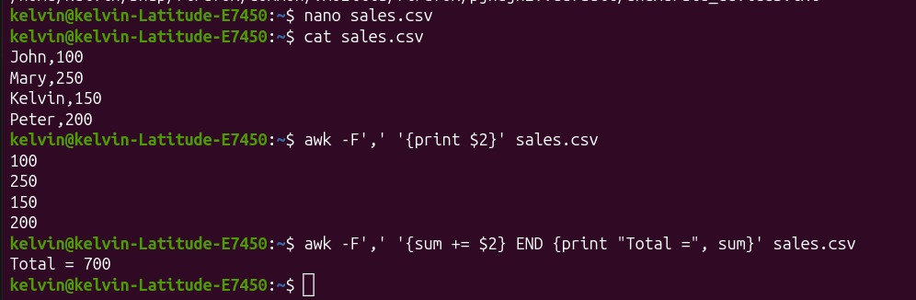
2 | We use find command to locate all .txt files in an directory tree modified | Yes | 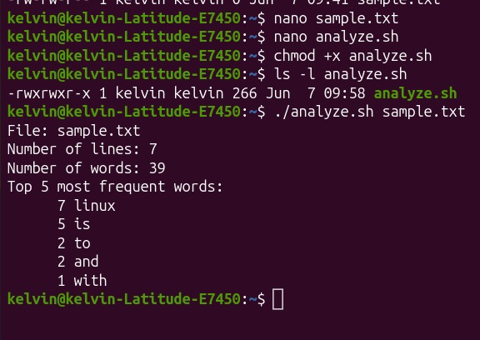
3 | By awk command we manage to extract the 2nd column from a CSV files and we wind the sum | Yes | 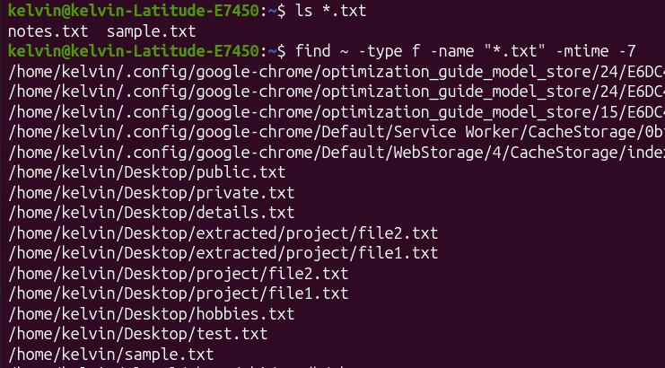
4 | We use sed command to perform an in – place sunstitution on the files | Yes | 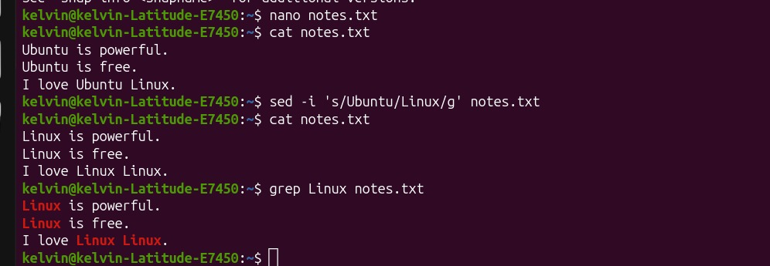
5 | We cahin 4 commands using pipes to perform a meaning data transiformation on a files | Yes |   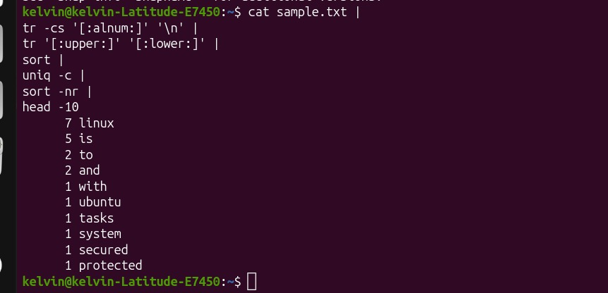
y
E. Command Evidence Log
Record the key commands your group ran. Attach screenshots after this page or include terminal output in an appendix.

# | Task Ref. | Command(s) Run / Description | Screenshot?
1
2
3
4
5
F. Creativity Challenge
Describe the real-world scenario your group chose and explain your creative design decisions.

Creativity Challenge
Scenario we chose:
Mini Log Analyzer

Our creative approach:

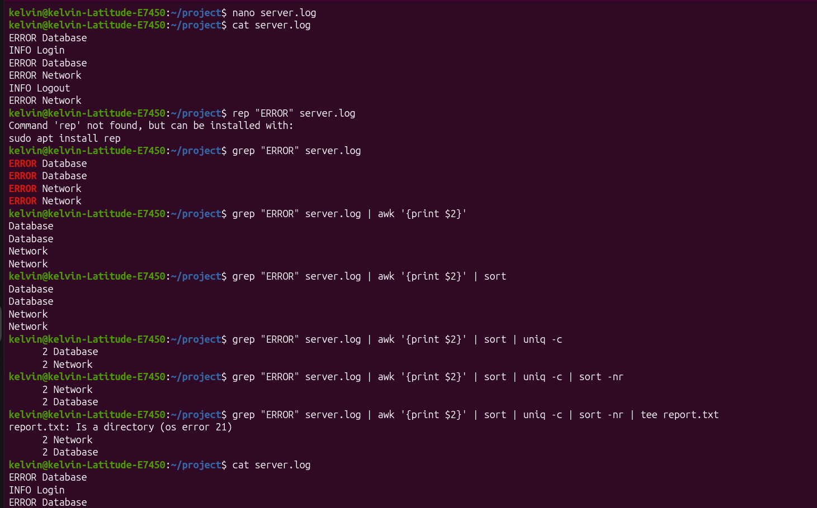

G. Self-Exploration (Individual — one per member)
Each group member must complete their own copy of this section. Photocopy this page or attach separate sheets — one per member.

Student Name: ________________________________ Reg. No.: ___________________________

Self-Exploration Findings
Exploration question answered:

Key commands tested:
tee and >
> and >>

What I discovered:
>
Writes output to a file only.
tee
Writes output to a file and displays it on the screen simultaneously.
> overwrites existing content.
>> appends content to the end of the file.

H. Group Member Contributions
Briefly describe what each member contributed. The percentages must add up to 100% per task (or you can distribute overall contribution).

Member Name | Specific Contribution | % Contribution
FREDY RESPICHIUS MATUNGWA | Core task Practitioner and report wroter | 20%
TEKLA JOHN MKUDE | Core task practitioner and challenge disigner | 20%
MARIA AGUSTINO KIKOTI | Report editor and screenshoter | 20%
GLORY PETER SALUM | Quality control and sreenshots | 20%
KELVIN EMANUEL SILVESTA | Lead technical writer | 20%

EASTC | DSU07210 Linux Systems Administration | 2025/2026

EASTC | DSU07210 Linux Systems Administration | 2025/2026

